**Automatic Texting Annotation Systems**



ع

E

Adding translation buttons in normal cell phone texting applications Can deeply enhance the performance and the repose time for all AI applications that are based on text annotations or analysis.

Each user can write his message in his own language and then click one button to send this message in a specific language (like English)

The AI system will receive the translated message in English (content is in only one language) in addition to the translated message the AI system will also receive the name of the original message language. Which will be handy in the case of system enhancements.

If all AI systems that rely on Text message analysis offload these language translations to the user side, this will make all AI and ML models simpler as they will rely on only one language.

AI applications that work on text categorization and response to this message based on this category, by adding this translation feature to texting applications in each cell phone, we can simplify the AI system into a queue of sets of keywords corpus that are used for your system categorization.

Text messages come to an AI system in one language then they pass through the AI system queue of keywords corpus that is used as gates for your message marking or grading it against each corpus category.

This is equivalent to doing categorization and automatic annotation in one step.

Consider this example for an AI application that prioritizes a text message for a healthcare provider. The user writes his message in his own language and sends his message by clicking on the [E] button to send the translation in [English]. Then the messages go through a queue of keywords corpus

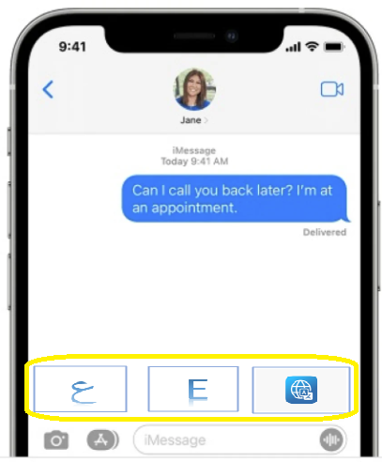

E

I have fever and skin rash and headache and fatigue

عندي سخنيه وطفح جلدي وصداع ووجع في المفاصل وضعف عام

blurry vision Fever or chills fever, nausea

very thirsty Cough headache, vomiting

Urinate (pee) a lot, Shortness of breath. fatigue, diarrhea, blood, or mucus

often at night difficulty breathing skin rash.  abdominal pain

dry skin Fatigue joint pain a high temperature of 38C or above

**This match index DOES NOT**  **need to add up to 100%**

**Match 4%**

**Match 10%**

Lyme Corpus

food poisoning Corpus

Lyme Corpus

**max**

**1%**

**19%**

Covid Corpus

Diabetes Corpus

The model will have its own internal set of false positive and false negative questions for each corpus with more detailed questions as a response to separate corpus intersections. and based on the response the model should combine both the original message and the second response and feed it again into the queue for marking and grading again for better categorization. This can continue until the model reaches a threshold categorization mark like 0% for example then prioritize this text message as its max mark corpus and send it to the healthcare provider that matches this corpus.

**Each Corpus Category**

**Corpus False Negative Questions**

**Corpus False Positive Questions**